# Bomb

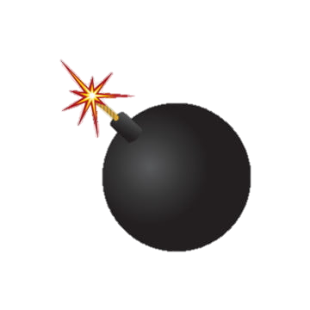

*One of the missions that new agents have to complete is called BombField. Your task is to implement the mission into a simple program.*

We get as input **the size** of the **field** in which our sapper moves. The field is **always a square**. After that, we receive the commands which represent the directions in which the sapper should move. The sapper **starts** from the **s**-position The commands will be **left/right/up/down.** If the sapper reaches the side edge of the field (left, right, up, or down), it **remains in its current position**. The possible characters that may appear on the screen are:

* **+** – regular position on the field.
* **e** – end of the route.
* **B** – bomb
* **s** – the place where the **sapper starts**

Each time when sapper finds a bomb, he deactivates it, and **replace "B" with "+"**. Keep track of the **count of the bombs**. Each time you find a bomb, you have to print the following message: **"You found a bomb!".** If the sapper **steps at the end of the route game are over (the program stops)** and you have to print the output as shown in the output section. After executing all of the commands there are only 2 possible outcomes (there are not going to be more cases):

* if you found all bombs – you win and the game ends
* if you reach the endpoint ("e"), you have to stop

Print the corresponding output depending on the case.

## Input

* **Field size** – an integer number.
* **Commands to move** the sapper – an array of strings separated by **","**.
* **The field: some of the following characters (+, e, B, s),** separated by whitespace (" ");

## Output

* There are three types of output:
  + If all of the bombs have cleared print the following output: "**Congratulations! You found all bombs!**"
  + If you reached the end, you have to stop moving and print the following line: **"END! {bombs left} bombs left on the field"**
  + If there are no more commands and none of the above cases happens, you have to print the following message: **"{bombs left} bombs left on the field. Sapper position: ({row},{col})"**

## Constraints

* The **input numbers** will be a 32-bit integer in the range [0 … 2 147 483 647].
* Allowed working time for your program: 0.1 seconds.
* Allowed memory: 16 MB.

## Examples

|  |  |  |
| --- | --- | --- |
| **Input** | **Output** | **Comments** |
| 5  up,right,right,up,right  + + + B +  + + + e +  + + B + +  s + + B +  + + B + + | You found a bomb!  END! 3 bombs left on the field | After executing all of the commands, the sapper moves to the endpoint. But there are some bombs left, so we print the information. |
| 4  up,right,right,right,down  + + + e  + + B +  + s + B  + + + + | You found a bomb!  You found a bomb!  Congratulations! You found all bombs! | The sapper reached the end of the field, so he remains in his position and we print the message. After all the bombs are found, we should stop the program and print the appropriate message. |